**Project Overview:**

The project aims to use the 20 variables over the course of 30 days to predict the return of shares over the course of 30 days. This will allow us to create a tool to facilitate users in getting better entry points for trades. The 20 variables are as follows:

1. 'Book_Value_Per_Share_*_USD',
2. 'Cap_Spending_USD_Mil',
3. 'Earnings_Per_Share_USD',
4. 'Free_Cash_Flow_Per_Share_*_USD',
5. 'Free_Cash_Flow_USD_Mil',
6. 'Gross_Margin_%',
7. 'Net_Income_USD_Mil',
8. 'Operating_Cash_Flow_USD_Mil',
9. 'Operating_Income_USD_Mil',
10. 'Operating_Margin_%',
11. 'Payout_Ratio_%_*',
12. 'Revenue_USD_Mil',
13. 'Shares_Mil',
14. 'Working_Capital_USD_Mil',
15. 'close',
16. 'dividend_amount',
17. 'high', ‘
18. ‘low',
19. 'open',
20. 'volume'

Given that we have chosen 131 tickers which made up the Dow Jones U.S. Technology Index, we expect them to be helpful in explaining the moves of one another. For example, an increase in Apple’s earnings per share will have a predictive impact on Google’s returns.

For our input data, I used 2 data source specifically and spliced it together to come up with the complete data set. The first data set is from AlphaVantage that provides me with the data on the equity prices such as high, low, open, share splits, volume and dividend amount. The second set of data is picked up from Morningstar. The data consist of the key ratios such as earnings per share, operating income, payout ratios, revenue and working capital. The companies report these data on a quarterly basis but Morningstar complies them on annual basis which is useful as it removes the seasonality factor of the data. Furthermore, some of the data by the companies have yet been reported and thus, I decided to forward fill the information i.e. filling forward the information such that the most recent readings will be used for the yet-reported data.

Initially, there was a plan to utilise Twitter data but I failed to properly classify the sentiment used and hence decided that it will be much more useful to utilise clean data rather than having a data point that is flawed. Furthermore, I am fortunate enough to obtain a lot more information from Morningstar and thus decided on removing the Twitter dependency but introduce more variables that I have sourced from Morningstar. The use of machine learning to predict stock market moves has always been an area of keen interest by the scientific community due to the huge amount of information that is available and in Appendix 2, I have attached some papers that I have referred to in this project.

**Problem Statement:**

I will look to build a stock price predictor that takes daily trading data over a certain date range as input and output buy or sell signals for the given query date.

The best proxy for the future is the recent past is the basis of the strategy to solve this problem. I believe that all shares exhibit similar behaviours which allows us to utilise what we have learned from the share price movements in Apple to predict the future movements of Facebook or Google. On this basis it will be incredibly useful for each factor to learn from one another and thus help us to maximise the dataset we have. Furthermore, a rise in Apple revenue also could drive other related companies like Micron or Intel and thus, we can utilise such cross company information to help refine the expected return of the shares.

One has to note that a 30 day return model is used as well and this is fundamental because it helps us avoid volatility which is intrinsic in the market. The expected solution will be one where we provide a complete set of information of all the related data and will be able to confidently tell us if the share price of our target company will rise or fall. This expected solution will be a dense neural network comprising of 3 layers. Between each of these layers, I look to drop out 20% of the point so as to ensure that we do not overfit the model to the data we have. It is extremely important to do that given that a lot of the information we have are correlated and thus resulting in us failing to see the wood for the trees.

This problem will be structured as a classification task where if the share price is higher in 30 days compared to that of today’s share price, it will be classed as 1 and if it is zero or negative, it will be classed as 0.

**Metrics:**

I decided to use the accuracy score which is a simple singular metrics to use which make the model output and that of the benchmark model easily comparable.

**Data Exploration:**

Looking at the data, I first spliced the various data sets into a single HDF. Thereafter, I took a first look at the first 5 rows of the dataframe. The first thing that jumped out was that there are various measures that has data that are empty. For example, the volume information of WP, Z and VSM is coming in as NaN.

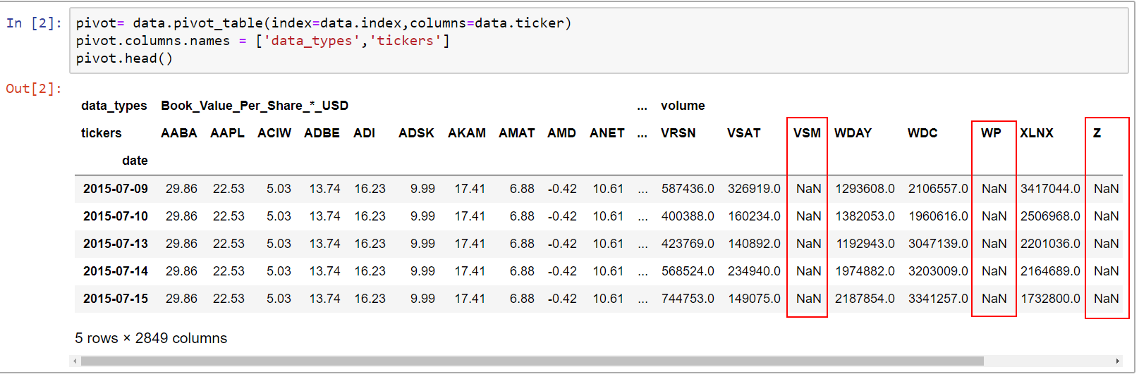

The data frame has 750 rows and 2849 columns where the rows are dates starting from 9th July 2015 to 28th June 2018. The columns have 2 layers namely data_types and tickers. Thus there are 23 different data types for each of the 131 unique tickers.

I created a new “missing_data” dataframe using a summary of “total” and “percent” dataframes. I then sorted it and noticed that out of the 2849 columns, there are 393 columns that have some sort of data that is missing in the columns. Each ticker is supposed to have 23 * 750 = 17,250 data points. Given that I will need to split the data into training and testing dataset, I decided to remove the tickers which has more than 15% of 17,250 data points missing. Thus, out of the 131 tickers, 4 of the tickers have more than 15% of their data missing as below:

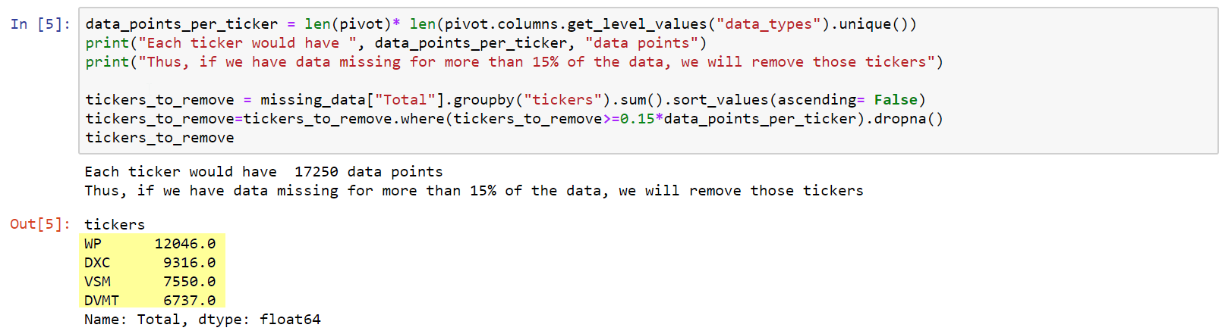

Thus we are left with 393-(4*23) = 301 columns that has some sort of missing data. Looking at the top 20 names that drive the highest percentage of missing data, I noticed that all the data that are missing are data from my Morningstar source

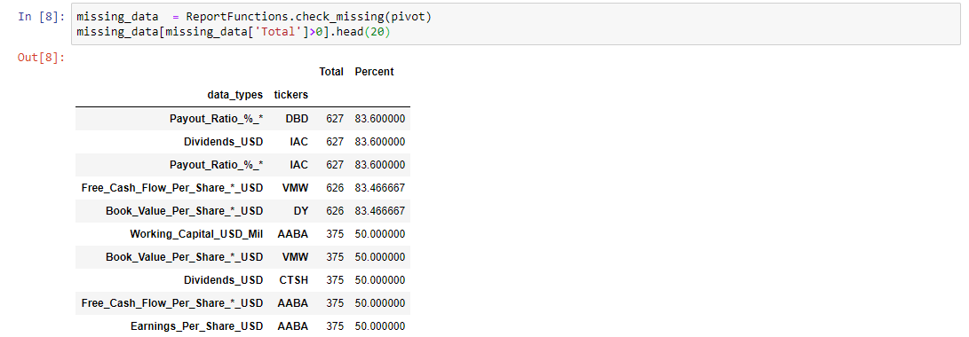

Looking at the column with the highest ratio of missing data, I noticed that DBD has missing payout ratio due to the fact that Payout Ratio is computed as Dividends divided by Earnings. However, given that the company made a loss in 2016, 2017 and 2018. It resulted in a negative Payout Ratio which the data omits. Thus, decide that I will replace all the Payout Ratio by dividing the Dividends by the Earnings and accept that there will be negative Payout Ratios.

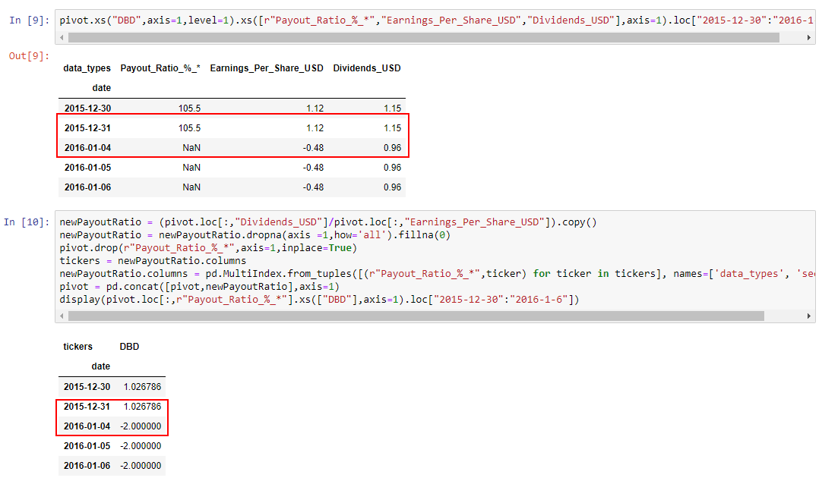After this cleaning, we note that we have significantly less dirty data and we note that they are generally concentrated in the following 5 fields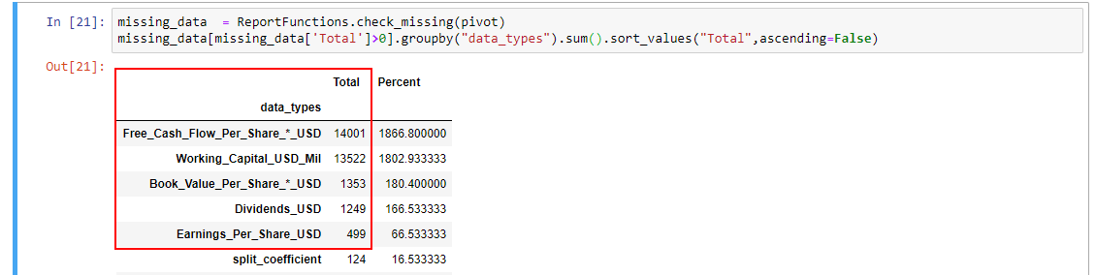

Given that we have 2 measures that are identical to each other namely

1. Free_Cash_Flow_Per_Share_*_USD
2. 'Free_Cash_Flow_Per_Share_*_USD'.

Thus, we can safely ignore the issues with the measure Free_Cash_Flow_Per_Share_*_USD

Also, I note that there are shares that do not distribute dividends like IAC in recent years hence, it is fair to fill the NaN values in as zero. The same applies to that of Book_Value_Per_Share_*_USD and Working_Capital_USD_Mil.

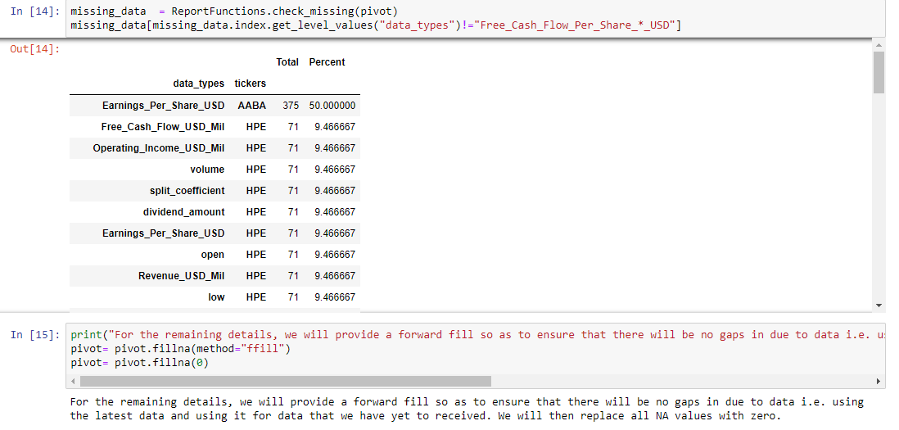Hence we are left with just some odd data points that are empty. AABA has incomplete information but given that we are in a situation where we are unable to get the completeness of the Earnings per share of AABA, I decide that I will forward fill so as to ensure that there will be no gaps in due to data i.e. using the latest data and using it for data that we have yet to received and replace all the remaining NA values with zero for simiplicity sake given that they are minimal.

Next, I sorted and printed all the tickers that has their stock split and when they were split.

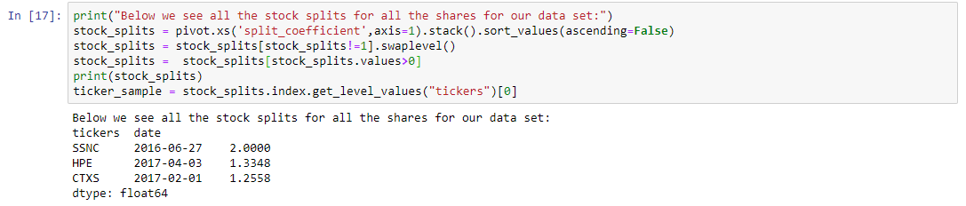

We note that 3 tickers namely SSNC, HPE and CTXS has had stock splits over the years and hence their data would be skewed and we can see the impact of a share split on the closing price of stock prices as seen below.

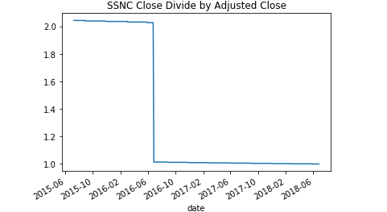

This is particularly evident in the data we have downloaded from Alpha Vantage. Thus, I decided to divide all the values before the stock split by the stock split ratio and hence making it consistent. We can easily see that upon the adjustment, the 4 variables namely ['high', 'low', 'open', 'volume'] are much smoother as seen in Appendix 1.

**Visualisation:**

Given the multitude of variables and cross variables available, I decide that I will be focusing on a single ticker to start off the visualisation. 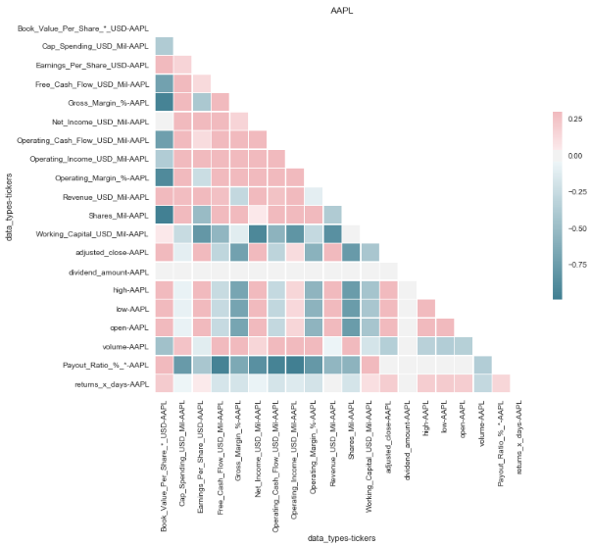

First and foremost, we noticed something that is rather unique. The data seems to negatively correlate with one another more than they are positively correlated with one another as seen by the skew in the colour scale where positive correlations goes up to 0.25 but the negative correlations goes as low as -0.75.

Secondly, we can see that Payout Ratio and Working Capital correlates negatively and strongly with the other variables and dividend amount has almost no correlation with any other variables. Furthermore, we see that our target variable “returns_x_days” does not seem to have very strong correlation with any other variables. This is confirmed by taking a specific look at the output below where the strongest negative correlation is with volume and the strongest positive correlation is 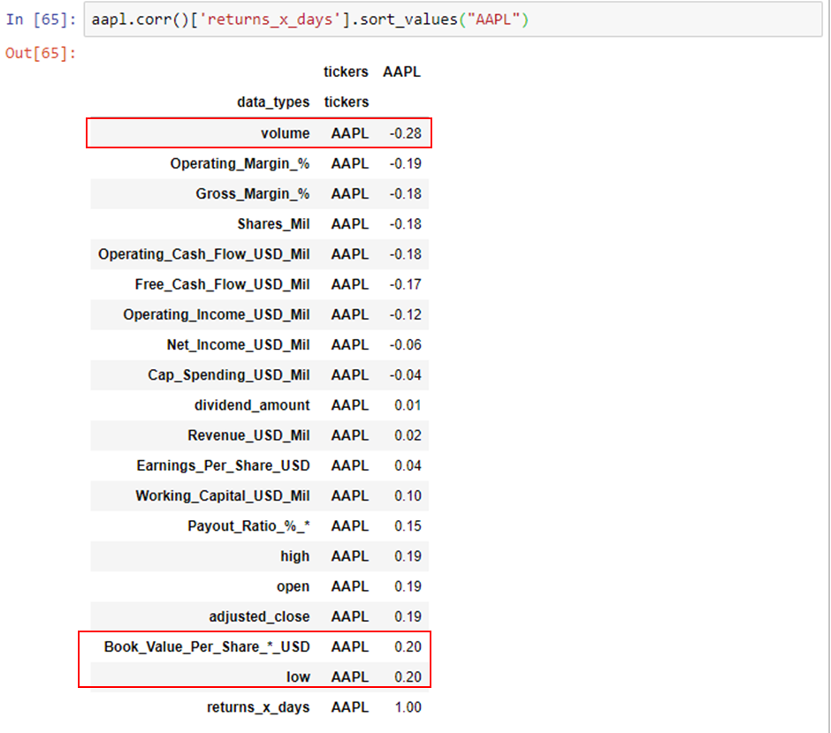with Book Value and daily low prices.

We can see that the distribution between positive returns and negative/ zero returns 30 days are generally distributed in a 60:40 split for Apple which is rather balanced.

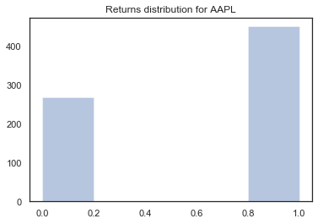

**Algorithm**

I chose to use a neural network to help predict the returns.

Given that the data are all highly correlated, I decided that it is a lot more useful to construct the layers of the neural network as dense layers. This allows all the information provided by each node to impact the end result without any bias. I included a layer of dropout after each dense layer so as to avoid overfitting and improve the robustness of the data. However, I have to flatten each input layer. This also means that the information containing in the time dimension gets diluted/ lost.

Dense Layer

* How it works?
  + Each layer for this case takes in the 20 variables over the last 30 days for all the 128 tickers and put them through a rectifier activation function which for this case is a rectified linear unit (ReLU). It is a linear approximation of a log function.
  + Each layer is trained by assigning and training the weights of nodes on the layers.
  + Dense layers essentially means all the input nodes are connected to the output nodes. If we have 50 input nodes and 30 output nodes, we will expect 50*30 = 1500 weights to be computed (ignoring any bias nodes).
* Strengths of Model
  + Dense layer is computational less expensive compared to other types of layers like recurrent layers
  + Using the ReLU activation unit, it is computationally efficient as it is a simple kinked linear function
  + It also avoids issues like vanishing gradient which makes it extremely expensive to get higher order differentiations done.
* Weakness of Model
  + Computationally intensive compared to sparse layers as weights for all input to all output nodes has to be computed through the forward and back propagation when we go through each epoch.
  + It assumes a linear relationship between the input nodes and output nodes of each layer. This means that we will require a second or third layers to model non-linear relationship or even more layers if we expect even more complex relationship. This makes it extremely expensive to scale up.

We can see that the average accuracy we had on the random forest classifier comes in at about 70.55% but using a simple 2 layered dense neural network, we can easily achieve a much higher accuracy of 86.67%.

However, due to flattening of the data, I believe there is data that is lost in the temporal dimension which means that I am not properly utilising our full data set. Thus, I created a second model using the Long Short Term Memory layer which is a kind of recurrent neural network that attempts to model time and series dependent behaviour (given that more recent information should always be given higher priority compared to a flattened Dense layer where all nodes are “equal”) .

Long Short Term Memory Layer (LSTM)

* How it works?
  + This is helpful in a time series dataframe as it helps to bring the context of “recentness” into the conversation.
    1. For example, the best estimate of Apple’s share price tomorrow will be Apple’s share price today and that is what recurrent networks offer that simple Dense layers do not.
  + That said LSTM model takes it a step further. It appreciates patterns and keys from the past that will be useful in the future.
    1. For example, if Apple’s share price rising on high volume means that it will more likely to be go higher while share price rising on low volume will mean that the move will likely reverse.
    2. If this behaviour has been observed previously, then we can be more confident on the right call when we witness similar surge in volume of shares traded.
* Strength of Model
  + It helps to bring about the idea of “recentness” and allow us to fully utilise the strong relationship we have in the data
* Weakness of Model
  + The strength of the model can also become its weakness. Without sufficient resets or “forget” gate within each nodes, we might end up with auto correlation issues where dirty data or nonsensical behaviours are reinforced and being seen as the rule rather than exceptions.

This resulted in a model that trained significantly longer, same degree of accuracy also slightly lower mean squared error than the simple Dense Neural Network. Similarly, I use a 20% dropout rate for the LSTM model so as to ensure that we do not over fit the data lower its performance in real-world scenarios.

All in all, after all the training and testing we can see that both LSTM and a simple Dense neural network outperforms that of a random forest classifier.

**Benchmark Model**

The benchmark model was chosen as the random forest classifier. This is a simple Ensemble method that is based on the Bagging. It breaks the complex problem down to simpler subsets which allow us to divide and conquer before merging the solutions. It has a huge benefit where there will be no issues with overfitting as the training and cross validation errors will continue to decrease when the model complexity increases (i.e. tree size increases).

The results from the Random Forest Classifier is being used as the benchmark for performance. For this case specifically, we achieved an average 70.55% accuracy on the benchmark model.

**Data Pre-Processing**

There is minimal data pre-processing required as a lot of the data issues were rectified when we were exploring the data. One significant advantage when we are using financial data is that the data is typically very complete and thorough and hence minimal processing is required. The data we have is processed in 2 main ways before I exposed them to the models mentioned above.

1. I applied min-max scaler to all the data in the data frame and scale them according to maximum and minimum of their readings over the sample period. The output of the scaler means that all the values are scaled between 1 and 0 where 1 is the largest reading in the series and 0 is the smallest number of the series.
   1. I chose this method of scaling over some other options like standardising the data using the standard deviation of the sample as I did not wish to make any assumption about the shape and structure of each variable.
2. The second processing is to create dataframes for the models.
   1. The first row where we have 30 days return for the target variable is 20 Aug 2015
   2. To predict the return for the target variable on 20Aug 2015 we require the 30 days preceding it i.e. we will require the data from 9July 2015 to 19 Aug 2015 as input variables.
   3. Thus we need to create a pre-processing function that creates a rolling 30 days window input variables for the prediction of the next day’s target variable.

**Refinements**

Along the way of working through this project, I realised that there are quite a lot of potential issues that I have failed to take into account when I initially proposed the model.

1. Initially, my proposal suggest using Twitter to generate an average “sentiment” measure for each day where 1 is a positive sentiment and 0 is a neutral or negative sentiment. However, the variation of the tweets from Twitter is vastly bigger and more complex. There are various nuances in language like sarcasm which makes it difficult to determine the sentiment. Furthermore, I did not consider the fact that there are various language that people tweet in and thus, in the end, I decide that it could very well be a project in itself.
   1. Thus instead of using a twitter sentiment, I decided that I will more “clean” data which I can obtain from Morningstar such as Payout Ratios etc.
2. Originally the proposed metric to use the area under the Receiver Operating Characteristic Curve where the curve is plotted by using the True Positive Rate (True Positive divided by the sum of False Negative and True Positive) and False Positive Rate (False Positive divided by the sum of False Positive and True Negative) with different thresholds for the logistic regression. However, this was scrapped after I ran the model once as I realised that 30 days return is often highly skewed. For example, the last 30 values of the 30 days return for AMD is all positive and there is only one class present in the y true value making it impossible for us to calculate True Positive and False Positive Rates and thus unable to utilise the ROC AUC score. Thus in the end, I decide to simplify the measurement metric by using the accuracy score.

**Results**

The final model is built using single layer of LSTM model. This model is chosen for the reasons listed below.

1. Simple
   1. A LSTM model means that it is a lot simpler than the Dense Neural Network. Simply looking at the hdf5 output of the weights used for the layers and the numbers of perimeters that are trained we can clearly see that the LSTM model has easily 6 times less parameters and the output weights for the corresponding model is also 6 times smaller as seen in the 2 screen shots below.

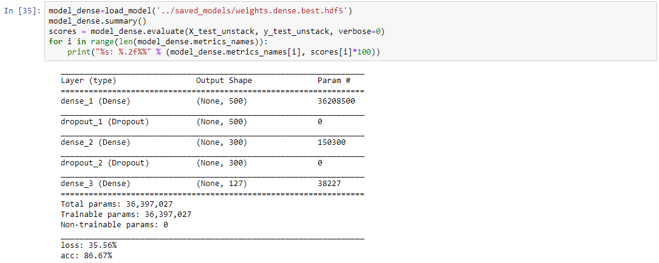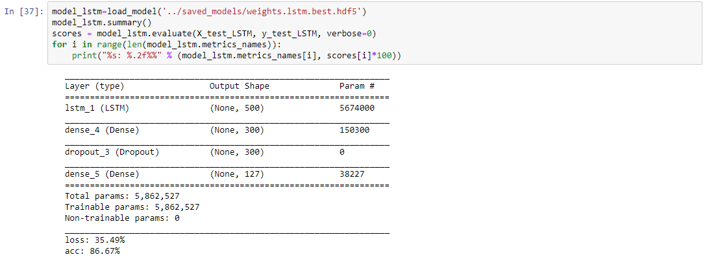

* 1. This means running the model and applying the training weights will be much faster.
  2. The LSTM model even has a marginal performance gain on the Dense Neural Network achieving the same accuracy with marginally lower mean squared error on the test set.

1. Superior to Benchmark
   1. As seen, we note that the accuracy score for the Random Forest Classifier is 70.55% but we handily beat the benchmark using the LSTM model and achieved a score of 86.67%. The accuracy score is a significant 22.84% improvement on the accuracy score of the Random Forest Classifier.

**Conclusion**

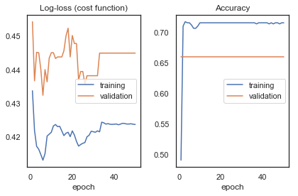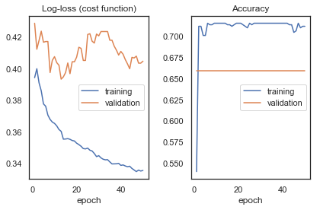Performance of Dense Layers Neural Network Performance of LSTM Neural Network

As we can see above, as we train the Dense Neural Network more, the training error gets significantly smaller but there is very marginal improvement in the validation set past the first 20 epochs. This is similar to the LSTM Neural Network that sees no incremental model performance improvement in mean squared error past the 30th epoch. Interestingly, the validation accuracy did not change over time. The other interesting thing is that for the LSTM Neural Network, there was no incremental changes or improvement to the model after the 30th epoch.

I do find the building up of individual layers of the neural networks very interesting. It comes across as more of an art rather than science. There is a fair bit of trial and error involved and it appealed to me in the free form sense but it also leaves me deeply dissatisfied knowing that there is probably some other methods or layer that might yield a better results. However, one thing is for sure. The model does perform and exceeds my expectations in generating the trading signals. The model can easily be extended to other types of equities like Bio-pharmaceuticals or Industrials as we will have access to similar set of data. Furthermore, we can easily extend the model by including non-standard variables such as Twitter data as what we originally intended which should easily better the result we have here. Also, I believe it will be incredibly useful to extend this model into a regression model rather than a classifier model. This is especially useful in terms of visualisatio and also will give us a very good idea of “distribution” of our results rather than the spot point. Distribution rather than binary classifiers has an additional benefit of allowing users to interpret “confidence” in the buy or sell signal. For example, a buy signal that is triggered because of an expected 30 days return of 0.1% is definitely less attractive than a buy signal that is generated due to an expected 30 days return of 5%. Armed with this information, it will help user to determine the size of the trade and make comparisons of purchasing signals. Especially because we are in a world with limited resource and to maximise the limited capital we have, we will have to pursue the most rewarding signals.

**Appendix 1**

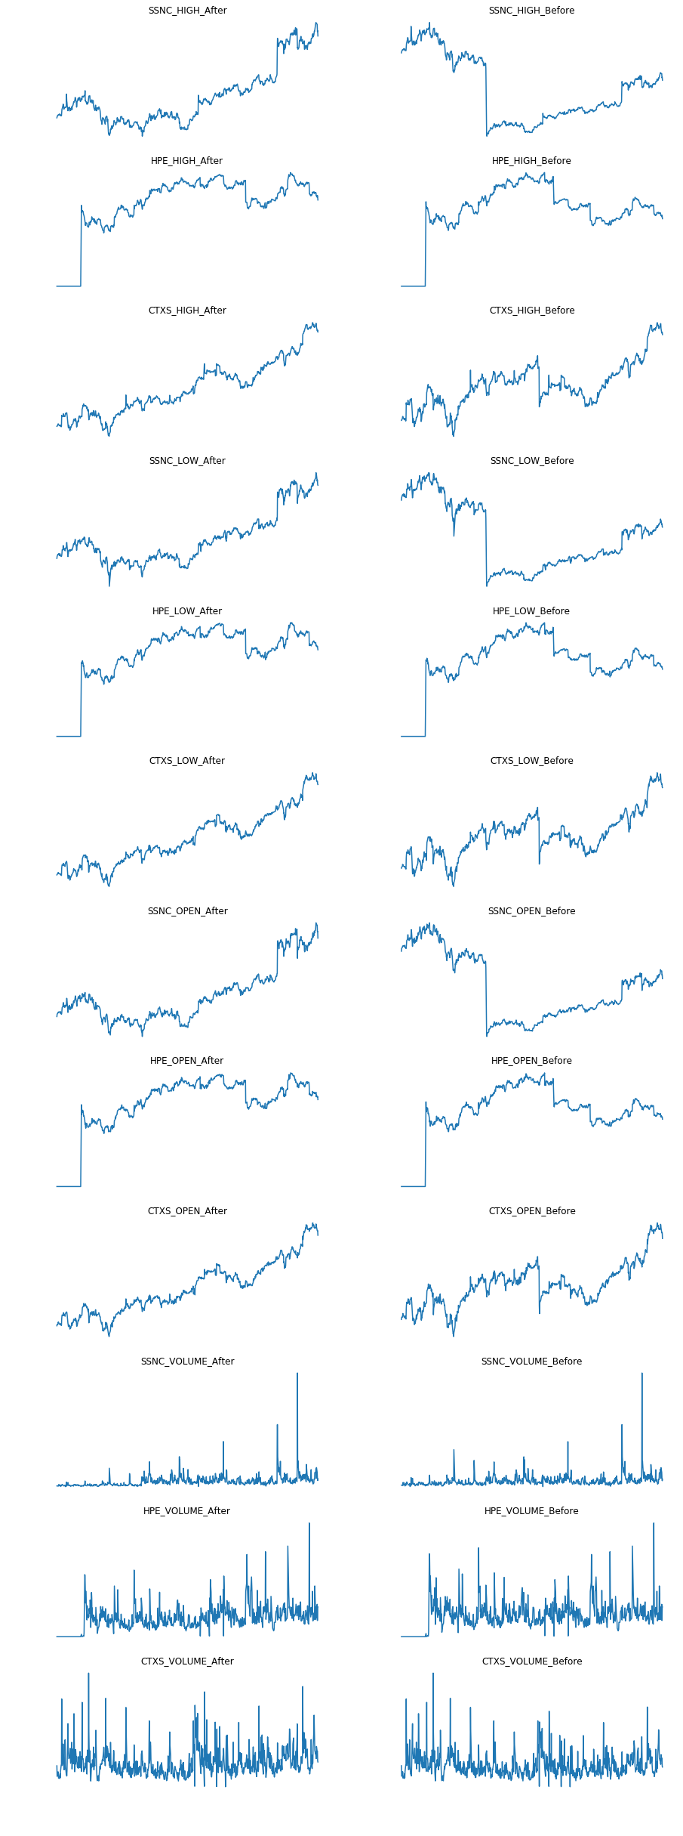

Appendix 2 - References

<https://stackoverflow.com/questions/332289/how-do-you-change-the-size-of-figures-drawn-with-matplotlib>

<https://stackoverflow.com/questions/18770504/resize-ipython-notebook-output-window>

<https://www.somebits.com/~nelson/pandas-multiindex-slice-demo.html>

<https://www.shanelynn.ie/select-pandas-dataframe-rows-and-columns-using-iloc-loc-and-ix/>

<https://blog.statsbot.co/time-series-prediction-using-recurrent-neural-networks-lstms-807fa6ca7f>

<https://stackoverflow.com/questions/39674713/neural-network-lstm-input-shape-from-dataframe>

<http://revistaie.ase.ro/content/57/16%20-%20Moldovan,%20Moca,%20Nitchi.pdf>

<https://www.worldscientific.com/doi/abs/10.1142/S0219024906003512>

<https://papers.ssrn.com/sol3/papers.cfm?abstract_id=1344230>

<https://medium.com/mlreview/understanding-lstm-and-its-diagrams-37e2f46f1714>

<https://gist.github.com/stared/dfb4dfaf6d9a8501cd1cc8b8cb806d2e>